**<**Learning Management System**>**

**Business Architecture Document**

**Version <1.0>**

**Revision History**

| **Date** | **Version** | **Description** | **Author** |
| --- | --- | --- | --- |
| 25/11/2024 | 1.0 | Final | Nguyễn Thị Hiền Anh Trần Thị Kim Ngân Vũ Thị Liên Nguyễn Duy Thùy Dương Đào Quang Khánh Nguyễn Quang Dũng Tạ Thị Tuyết Lan |
|  |  |  |  |
|  |  |  |  |
|  |  |  |  |

**Table of Contents**

1. Introduction 4

1.1 Purpose 4

1.2 Scope 4

1.3 Definitions, Acronyms, and Abbreviations 4

1.4 References 4

1.5 Overview 4

2. Architectural Representation 4

3. Architectural Goals and Constraints 5

4. Business Process View 5

5. Organization Structure View 5

5.1 Business Use-Case Realizations 5

6. Cultural View

7. Human Resource Aspects View 6

8. Domain View 6

9. Size and Performance Goals 6

10. Quality Goals 6

**Business Architecture Document**

# **Introduction**

## **Purpose**

Business Architecture Document provides a comprehensive architectural overview of the system, using a number of different architectural views to depict different aspects of the system. It is intended to capture and convey the significant architectural decisions that have been made. This document is in the BMP folder of our project.

## **Scope**

This document applies to the Learning Management System.

## **Definitions, Acronyms, and Abbreviations**

User: Those who use the system.

Admin: Those who control the system.

## **References**

This document is referenced from the Software Architecture Document.

## **Overview**

The Business Architecture Document includes several sections.

The first section is Introduction about the purpose, scope, definitions, acronyms and abbreviations, references, and overview.

The second section is Architectural Representation – describes the business architecture of the Learning Management System and how it is represented.

The third section is Architecture Goals and Constraints – contains some factors that have an impact on the business architecture. There are some other sections:Market View, Business Process View, Organization View, Culture View, Human Resource View, Domain View, Size and Performance Goals, and Quality Goals.

# **Architectural Representation**

The Learning Management System is divided into 2 main parts:

For students, it supports some of the management functions about View Course, Submit Assignments and Quizzes, Take test/quiz, Track Progress, Participate in Discussions and View Announcements.

For instructors, it supports some of the management functions about Manage Courses Content, Grade Assignments, Monitor Student Progress, Manage Announcements and Manage Discussions.

For administrators, it supports the management functions of Manage Users, Manage Course, Manage Course, Generate Reports, Configure System Settings, Configure System Settings and Post general announcements.

# Architectural Goals and Constraints

The architecture is significantly impacted by the users:

The architecture of the Learning Management System needs to be adaptable and simple for users to update.

Regular updates to the Learning Management System security measures are necessary to protect user accounts from emerging dangers.

# **Business Process View**

This section is referenced from section 4.1 of the Software Architecture Document. Learning Management System Business Process View includes:

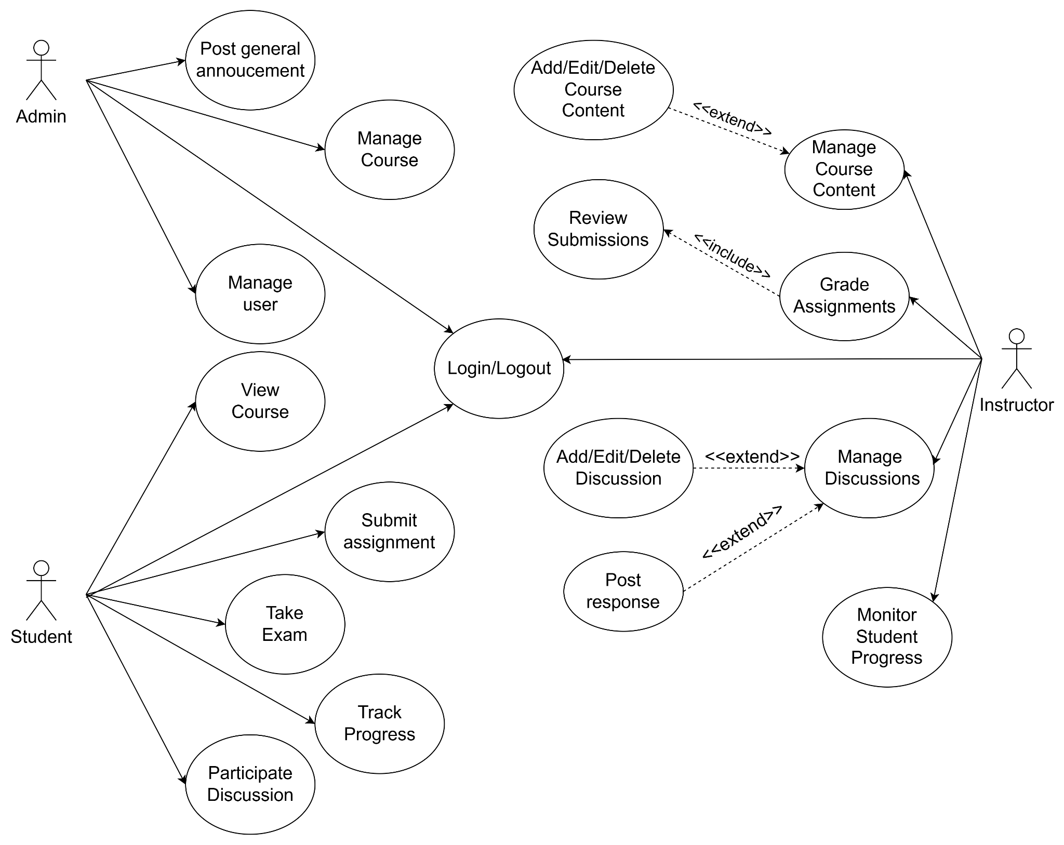

# **Organization View**

## **Business Use-Case Realizations**

This section is related to the section 4.2 of the Software Architecture Document.

# Cultural View

Global Training: Provide opportunities for learners in many parts of the world to access rich learning content, contributing to comprehensive knowledge development and cultural exchange.

Content Diversity: Support courses in many fields, languages, and levels, promoting integration and improving community knowledge.

# Human Resource Aspects View

The HR team focuses on recruiting, developing, and retaining excellent employees, while building a positive and effective working environment for all members.

# Domain View

NA.

# Size and Performance Goals

The LMS can support 5000 users simultaneously and expand to 15,000 users when necessary.

Response time does not exceed 1 second to ensure the best user experience.

# Quality Goals

User-friendly interface for all users, including students and lecturers.

Business architecture needs to be logically designed and flexibly expanded to meet the needs of system development and serve diverse user groups.